Warren H. Marshall Jr.
September 20, 1946 – November 5, 2013

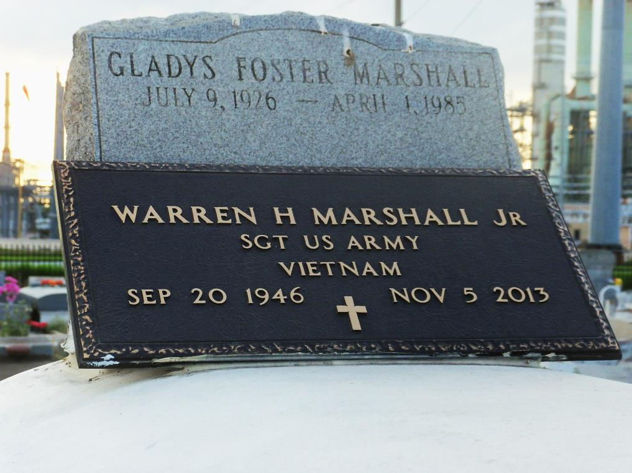
Photo by GeniHound

Warren H Marshall, Jr. entered into eternal rest on Tuesday, November 5, 2013 at the age of 67 yrs. He leaves to cherished his memories his beloved wife Gloria C. Marshall, two sons Warren Marshall III, Donald Dillon (Shekina), four daughters Laquanada Smith (Reginald), Angela Franklin, Shoneeka Dillon (Kim), and LaKenya Johnson. Three sisters Lorraine (M.S. Daniels), Debbie Wickliff, Brenda Marshall. Three brothers Larry, Willard and DeWight Marshall. Also survived by a host of grandchildren, other relatives and friends.
Relatives, friends, Pastor, officers and members of First Emanuel B. C. are invited to attend the Celebration of Life on Friday, November 15, 2013 at 11:00 AM at First Emanuel Baptist Church, 1829 Carondelet St. Visitation begins at 10:00 AM until of service. Pastor Charles J. Southall, III will officiate. Internment Zion Travelers B. C. Cemetery, Garyville, LA. Arrangements entrusted to Gaskin-Southall-Gordon-Gordon-Mortuary, 2107 Oretha C. Haley Blvd., NOLA (504)566-9000. Please view and sign guestbook at NOLA.com/obits.
Times-Picayune, The (New Orleans, LA) - Wednesday, November 13, 2013
Contributed by Jane Edson

