Alma (Robertson) McGee
August 23, 1926 – February 2, 2003

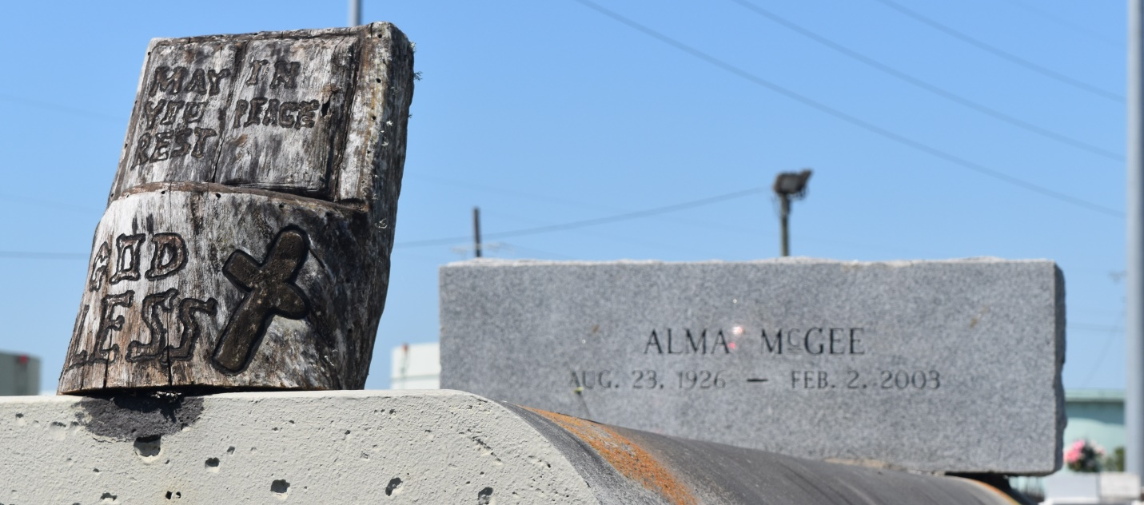

Alma Robertson McGee, a homemaker, died Sunday of undetermined causes at River Parishes Hospital. She was 76. Mrs. McGee was a lifelong resident of Reserve. Survivors include five sons, Clarence Robertson Sr., Edward McGee Robertson, Willie McGee, Albert "Red" Robertson and John McGee; three daughters, Anna Mae Griffith, Alberta Porter and Rose McGee; 38 grandchildren; 63 great-grandchildren; and two great-great-grandchildren. A wake will be held Friday at 7:30 p.m. at New Rescue Mission Baptist Church on East 14th Street in Reserve. A dismissal will be held Saturday at 11 a.m. Burial will be in Zion Travelers Cemetery in Reserve. Hobson Brown Funeral Home is in charge of arrangements.

Times-Picayune, The (New Orleans, LA) - Thursday, February 6, 2003
Contributed by Jane Edson

