Willie Lee McQuater
November 13, 1930 – October 28, 2000

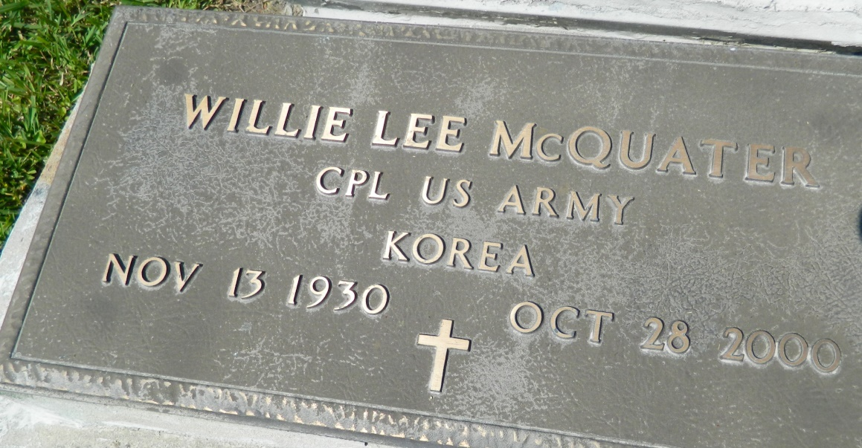

GRAMERCY - Willie Lee McQuater, a native of Reserve and resident of Lutcher, died Oct. 28. He was the stepfather of Lou Ida Wilson and Lorraine Wilson.
He was the son of the late Isaac and Celestine McQuater and brother of Isaac "Pop," Ernest "Joe" and Charles "Scrap" McQuater.
He is also survived by 15 grandchildren and 10 great-grandchildren.
Services are today at 11 a.m. at New Zion Baptist Church, Gramercy, with interment at Zion Travelers Cemetery, Lions.

L'Observateur (La Place, LA) - Friday, November 10, 2000
Contributed by Jane Edson

