Donald J. Melancon Sr.
March 5, 1950 – February 1, 2005

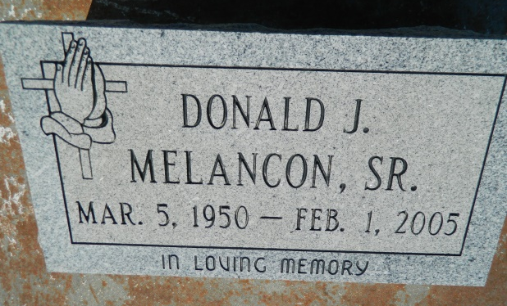

Donald Melancon Sr of Reserve, LA at East Jefferson Hosp. on Tues., Feb. 1, 2005. Husband of Betty Smith Melancon. Father of Leslie (Joel) Fluence, LA Shonda (Derrick) Henderson, Donald (Felicia) Melancon, Jr. and Durell (Lil Bit) Melancon. Brother of Evangelist Betty M. Harvey and Roy Melancon. Also survived by (7) grandchildren. Preceded in death by his parents Daniel and Lillie Melancon. A native of Convent, LA and a resident of Reserve, LA. Age 54 yrs.
Relatives and friends of the family, also pastor, officers and members of the St. Joe Missionary B.C. and neighboring churches, employees of St. John Parish School System, East Jefferson General Hospital, Contractor's Supply and Equipment, Alpha Supported Living Services, former employees of Constar Plastics, are invited to attend the funeral services on Sat., Feb. 5, 2005 at 10:00 a.m. from the St. Joe Missionary B.C., 2256 Alexander St., Lutcher, LA. Rev. Clarence Williams Sr. officiating. Interment Zion Travelers Cemetery, Reserve, LA. Visitation at the church after 9:00 am on Sat.
The Baloney Funeral Home, 399 Earl Baloney Dr., Garyville, LA 70051, (985) 535-2540

Times-Picayune, The (New Orleans, LA) - Friday, February 4, 2005
Contributed by Jane Edson

