Everlena (Thomas) Melancon
June 9, 1924 – April 25, 2010

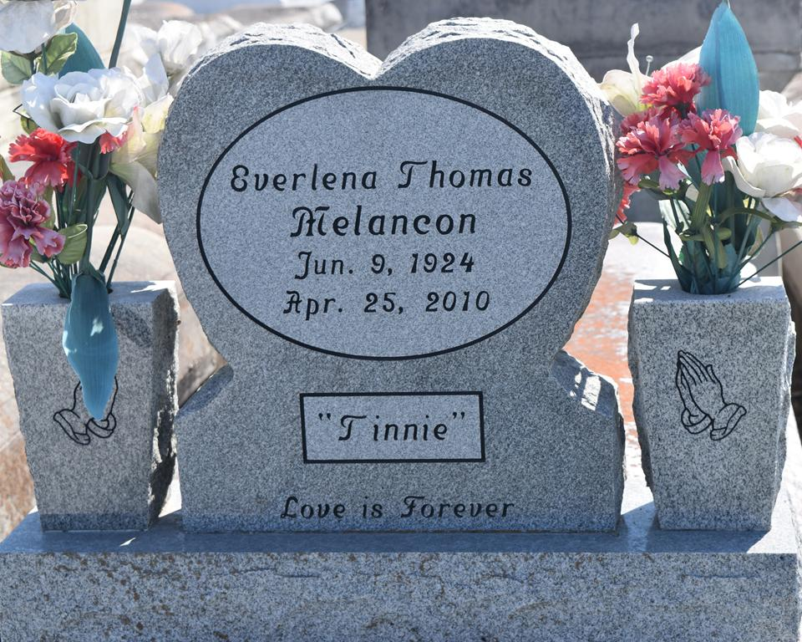

Everlena Thomas (Tinnie) Melancon, a resident of Reserve, LA, departed this life on April 25, 2010 at River Parish Hospital. She was 85 years old.
Visitation will be at Hambrick's Family Mortuary, 808 W. Worthey Rd., Gonzales, LA, on Wednesday, May 5, 2010 from 5 pm - 8 pm and at Mount Zion BC, 100 Second Street, St. Rose, LA, and on Thursday, May 6, 2010 10:00 am - 11:00 am religious time. Conducted by Rev. Isiah Franklin, Jr Pastor. Internment Zion Travelers BC Cemetery, Reserve, LA.
She leaves to cherish her memories of Stella Mae White and Evelyn Basile both of LaPlace, LA and Elouise Morris of Montz, LA; sons Calvin Doss and Kenneth Melancon both of Reserve, LA; She was a grandmother of 40 and great grandmother of 85 and a great great grandmother of 34; sister of Albert (Vannessa) Thomas, Reserve, LA, Ora Lee Ellis of LaPlace, LA and two Godchildren Lillie Mae Jones and Frank Gardner, a son-in-law Eldrid Morris, Harold Basile and Larry Eugene, a daughter-in-law Tonya Melancon and former daughters-in-law Laura Scott and Loretta B. Jackson, a sister-in-law Mattie Thomas, and a host of nieces, nephews, cousins, other relatives and friends.

The Times-Picayune, New Orleans, Louisiana
May 5, 2010

