Karen Ann Miles
1957 – April 9, 2018
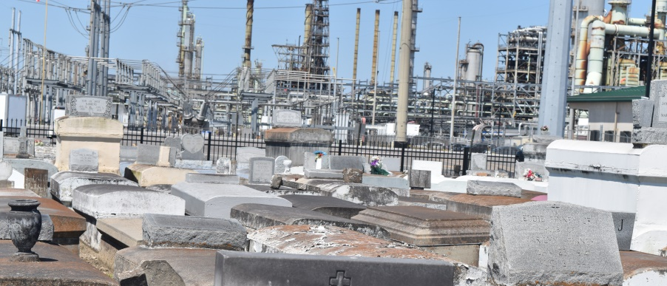

Karen Ann Miles, on April 9, 2018 at her home in LaPlace, LA. She was 61yrs. She leaves to cherish her memory four beautiful children, Nicole, Danielle, Brandy, and Ebony Miles; Siblings, Fredrick, Alana, Janet, Johnny Miles and Althea Favorite. She also leaves nine grandchildren, Justin Stewart, Dajsha Miles, Dajohn Miles, Jahkier Stewart, Jordan Jackson, Jace Miles, Denim Miles, Tru Washington, Braden Miles and one great grandchild, Corbrey Miles. She was preceded in death by her parents Samuel and Una Miles as well as siblings Aaron and Vera Miles.
There will be a celebration of her life on Saturday, April 14, 2018 for 10:00 AM from First Community Antioch Church, 10860 LA-3125, Gramercy, LA. Rev. Ferdinand Gaines, pastor. Viewing from 9:00 am until service time. Interment Zion Travelers Cemetery, Reserve, LA. Treasures of Life Funeral Services, 315 E. Airline Hwy, Gramercy, LA 70052 entrusted with her final care.
“When someone you love becomes a memory, that memory becomes a “TREASURE!”
www.treasurefunerals.com (accessed 10/7/2018)

