Lillian J. Miles
July 4, 1923 – November 1, 2003

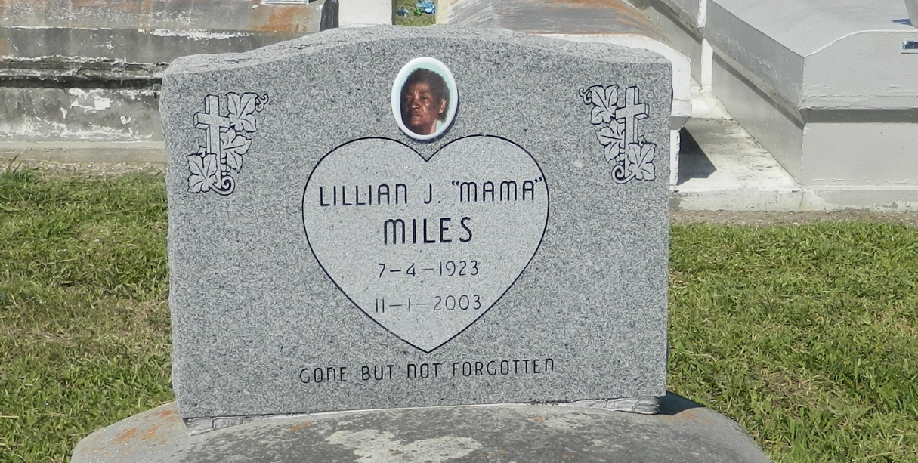

Lillian Miles, a homemaker, died Nov. 1 at her home. She was 80. Ms. Miles was a lifelong resident of Garyville. She was a member of Zion Travelers Baptist Church. Survivors include seven sons, Elton, Herman, Leonard, George, Mark, Eric and Whitney Miles; three daughters, Lillian and Hilda Gardner, and Mary Jones; three sisters, Ceceile, Valentine and Audrey Miles; 31 grandchildren; 40 great-grandchildren; and four great-great-grandchildren.

A funeral will be held today at 11 a.m. at Zion Travelers Baptist Church in Lyons. Visitation will begin at 9 a.m. Burial will be in the church cemetery. The Baloney Funeral Home handled arrangements.

Times-Picayune, The (New Orleans, LA) - Saturday, November 8, 2003
Contributed by Jane Edson

