Allen L. Millet
Abt. 1945 – December 7, 2013
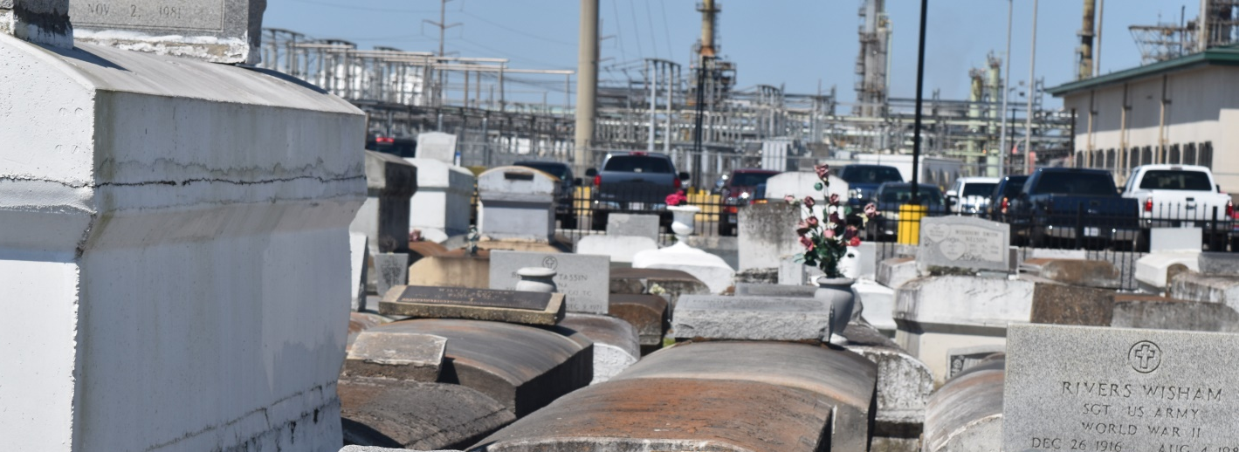

Allen L. Millet, 58, died on Saturday, Dec. 7, 2013.
He was the beloved father of Chris Millet (Jessica) and the late Chance Millet, grandfather of Tyler, Joshua and Christian Millet, son of the late Allen A. and Rosemary Verret Millet and brother of Jennifer Cherry, Patricia Millet and Melanie Millet. He was a native and resident of LaPlace.
Relatives and friends are invited to attend Memorial services. Visitation will be held at Millet-Guidry Funeral Home, 2806 W. Airline Highway, LaPlace, on Friday, Dec. 13, 2013, from 8 a.m. to 10 a.m., followed by religious services in the funeral home chapel at 10 a.m. Burial will follow in St. John Memorial Gardens.
L’observateur, LaPlace, LA; Tuesday, December 10, 2013

