Lurline Moore
April 17, 1941 – August 22, 2000

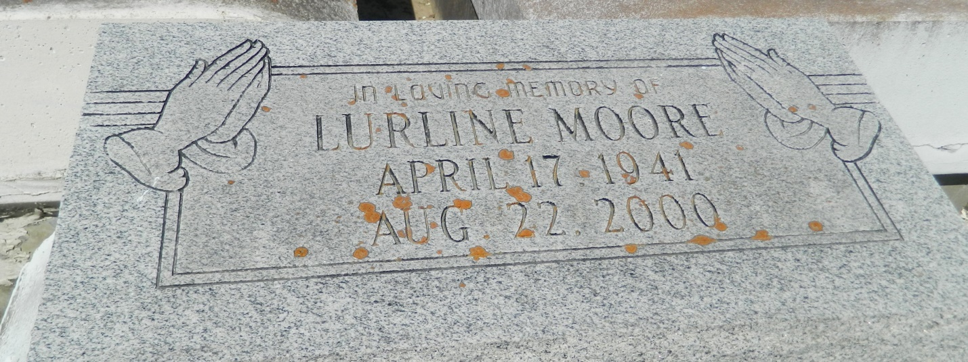

Lurline Moore, a homemaker, died Tuesday of cancer at Charity Hospital. She was 59. Ms. Moore was a lifelong resident of Mount Airy. She attended Fifth Ward High School. Ms. Moore was a former employee of Park Fountain and Crystal Preserves. She was a parishioner of St. Hubert Catholic Church in Garyville. Survivors include her mother, Lucille Moore; a son, Otis Moore; a brother, Robert Moore Jr.; a sister, Margie Moore; a stepfather, Melvin Marshall; six grandchildren; and a great-grandchild. Visitation will be today at 4 p.m. at Bardell's Mortuary in Mount Airy and Saturday at 8 a.m. at St. Hubert Catholic Church, 176 Anthony F. Monica St. in Garyville. A Mass will be said at 9:30 a.m. Burial will be in Zion Travelers Cemetery in Lions. Bardell's Mortuary is in charge of arrangements.

Times-Picayune, The (New Orleans, LA) - Friday, August 25, 2000
Contributed by Jane Edson

