Taytum Aevon Moore
August 15, 2005 – May 25, 2008

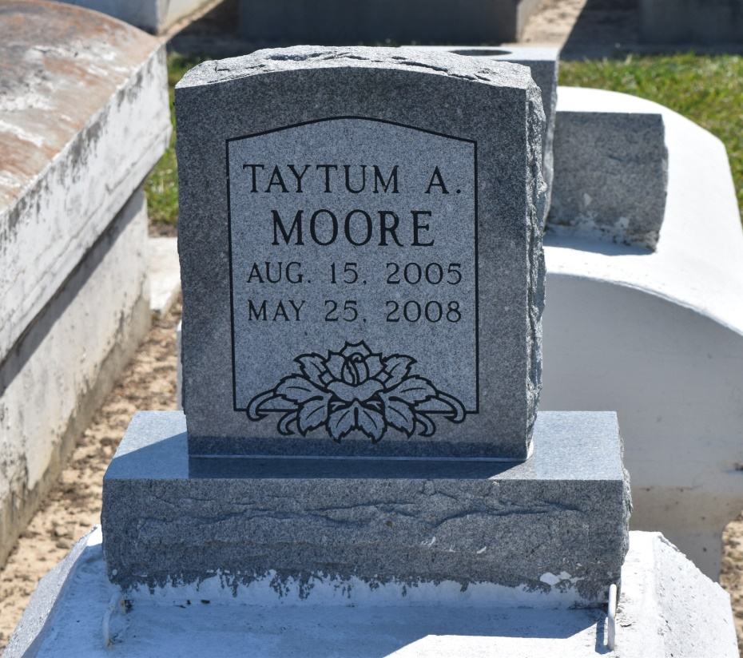

Our Princess Taytum Aevon Moore, age 2, passed away peacefully on Sunday, May 25, 2008 in Laplace, La. Daughter of Tremayne and Margo Moore. Sister of Torrian J. Moore and A'Hnesty Alexander. Granddaughter of Edna D. Robertson, Robert Moore, III, Lurline Warren and Michael Warren. Great Granddaughter of Mr. and Mrs. Robert Moore, Sr., Elouise Duhe, Edwin Duhe Sr, Isabella Gerard, Helen Warren and the late Earl Gerard, Sr., and Joseph Warren. A native and resident of Laplace, La.
Pastor, Officers and members of Zion Travelers Baptist Church and all neighboring churches are invited to attend the Funeral Service on Thursday, May 29, 2008 at 10:00a.m. from the above named church, 713 Walnut St., LaPlace, LA, with Rev. Isaiah Franklin, Jr. officiating. Interment church cemetery. Viewing on Tuesday from 9:00 until Service time.
Service Entrusted to Hobson Brown Funeral Home, Garyville, La.

Times-Picayune, The (New Orleans, LA) - Wednesday, May 28, 2008
Contributed by Jane Edson

