Sydonna (Esko) Morris
April 14, 1975 – January 6, 2001

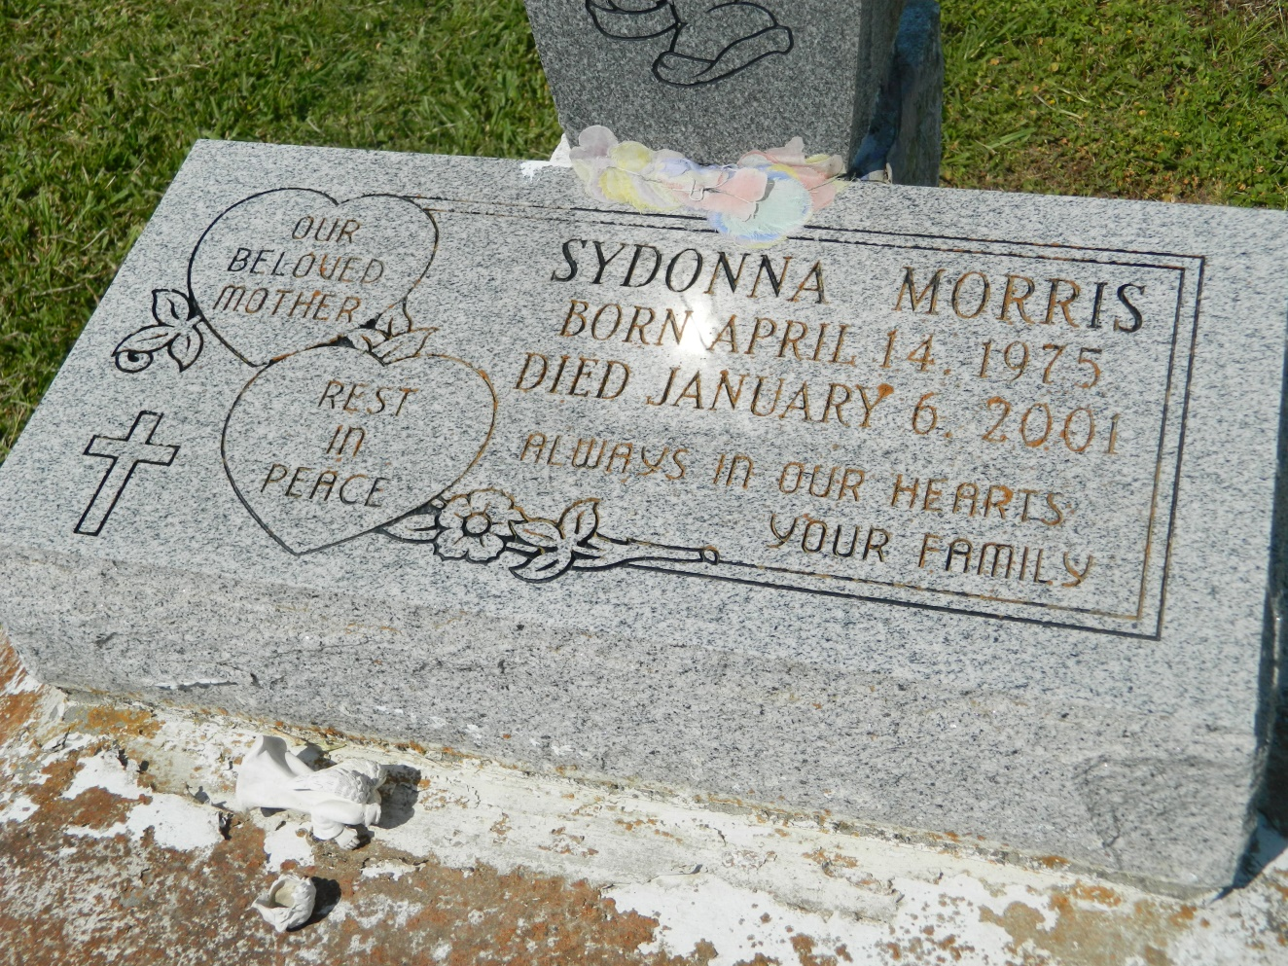

MT. AIRY - Sydonnia Morris, 25, a native of Garyville and resident of LaPlace for 10 years, died Jan. 6. She was the mother of Joi Morris and Jasmin and Jontrey Esko. She was also the daughter of Lester Sr. and Linda Morris Esko and sister of Shannon Florent, Sandra Taylor, Lester Jr., Linwood, Manuel and Kendall Esko and Adrian and Emmanuel Duhe. She is also survived by a grandmother, Vivian Braxton.
She was a secretary for the St. John the Baptist Parish Housing Authority.
Services were Jan. 11 at St. Mark Baptist Church, Mt. Airy, with interment at Zion Travelers Cemetery, Lions.

L'Observateur, LaPlace, LA; January 13, 2001

