Ricky Nevers Sr.
August 27, 1964 – May 15, 2002

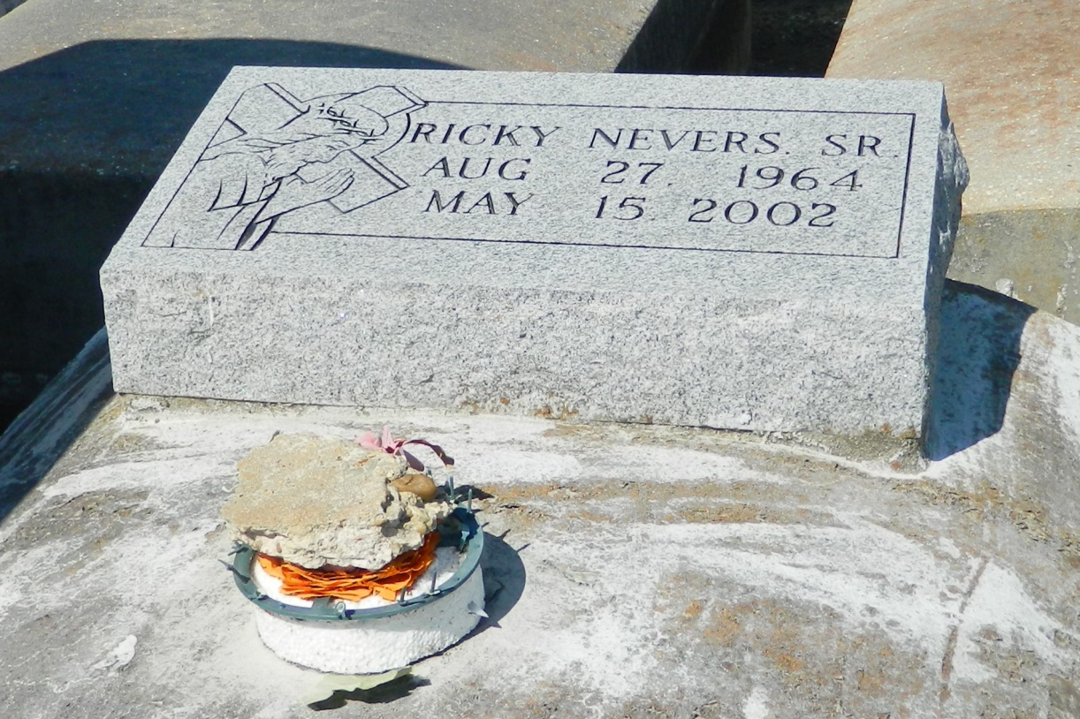

LAPLACE - Ricky Nevers Sr., 37, a native of Garyville and resident of LaPlace, died May 15. He was the husband of Belinda Borne Nevers, father of Kristy, Ricky Jr. and Rickitta Nevers and guardian of Edwin Jr. and Emohni Florent.
He was the son of Robert and Janice Nevers Eubanks and brother of Shawanda Bryant and Robb and Teta Nevers.
Services were May 20 at Milesville Memorial Church of God in Christ, LaPlace, with interment at Zion Travelers Cemetery, Lions.

L'Observateur (La Place, LA) - Saturday, May 25, 2002
Contributed by Jane Edson

