Marguerite (Smith) Perrilloux
May 29, 1925 – December 23, 2006

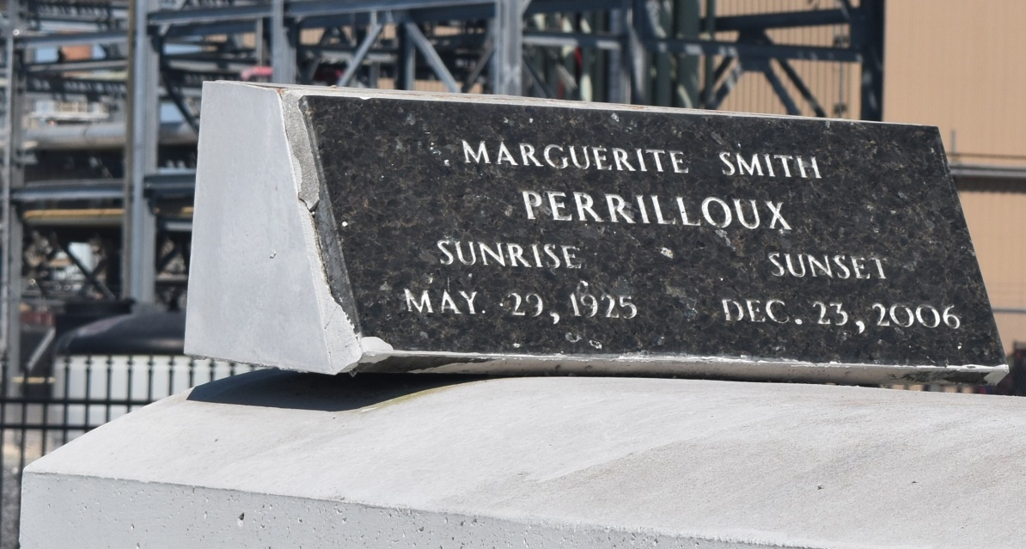

Marguerite (Magette') Perrilloux on Saturday, December 23, 2006 at River Parishes Hospital, LaPlace, LA. Daughter of the late Valentine Wallace and Noel Smith. Wife of Remey Perrilloux, Sr. Mother of Cheryl P. Frank, Elizabeth P. Thomas, LouTricia P. Batiste, Pamela P. Smothers, Patronella P. Williams, Otis, Dale, Bruce, Carl, Quincy Joseph, Adrian and Timothy Perrilloux and the late Remey Perrilloux, Jr. Sister of Victoria Spencer, Clarence Smith, the late Noel Smith, Jr., Eleanor Batiste and Stella Mae Victor. Also survived by a host of grandchildren, great and great-great grandchildren, nieces, nephews, other relatives and friends. Age 81 years. A native and resident of Reserve, LA.
Relatives and friends of the family, also priest and parishioners of Our Lady of Grace Catholic Church and all neighboring churches are invited to attend the Mass of Christian Burial at Our Lady of Grace Catholic Church, 772 Highway 44 (River Road), Reserve, LA. on Friday, December 29, 2006 at 10:00 AM. Fr. Joseph Rodney, Celebrant. Interment Zion Travelers Cemetery, Reserve, LA. Visitation at the above named church from 9:00 AM until Mass time.
SERVICED BY ROBOTTOM

Times-Picayune, The (New Orleans, LA) - Thursday, December 28, 2006
Contributed by Jane Edson

