Carolyn (Nicholas) Placide
May 18, 1945 – March 30, 2010

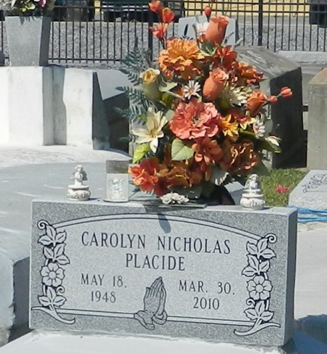

Carolyn Placide departed this earthly life and entered into eternal rest on Tuesday, March 30, 2010 at East Jefferson General Hospital of Metairie, LA. Beloved daughter of Caldonia Nicholas and the late Irvin Nicholas Sr. Loving mother of Renel Joseph, Tanya Joseph, Randall (Kelli) Joseph-Placide, Rodney (Christine) Joseph-Placide. Step-mother of Gloria Keller, Sheryl Davis, Karen (John) Landry, Kendell Taylor, Daryl Taylor, Rachel Turner, Wilson (Elvira) Placide Jr., Perry (Melissa) Placide and Terrance Placide. Sister of Brenda Nicholas, Irvin Nicholas Jr., Ronald Nicholas and the late Donald Nicholas Sr. A devoted friend of Stephanie Cooks. She is also survived by a host of nieces, nephews, other relatives and friends.
Relatives and friends of the family, also Pastors, Officers and Members of True Light Baptist Church of Garyville, LA, employees of St. John Parish Sheriff Office, Southeast Veteran War Home, St. John Parish Schools, New Orleans Hilton, and all neighboring churches are invited to attend the Funeral Services on Tuesday, April 6, 2010 at 11:00 AM at the True Light Baptist Church, 258 Little Hope St., Garyville, LA. Rev. Wesley Anderson Sr. officiating. Interment in Zion Travelers Cemetery of Reserve, LA. Visitation will be at the above named church from 9:00 AM until service time. There will be no viewing at the end of service.
Bardell's Mortuary of Mt. Airy, LA in charge. Information: 985-535-6837

Times-Picayune, The (New Orleans, LA) - Monday, April 5, 2010
Contributed by Jane Edson

