Khaduah Preston
May 22, 1994 – November 15, 2004

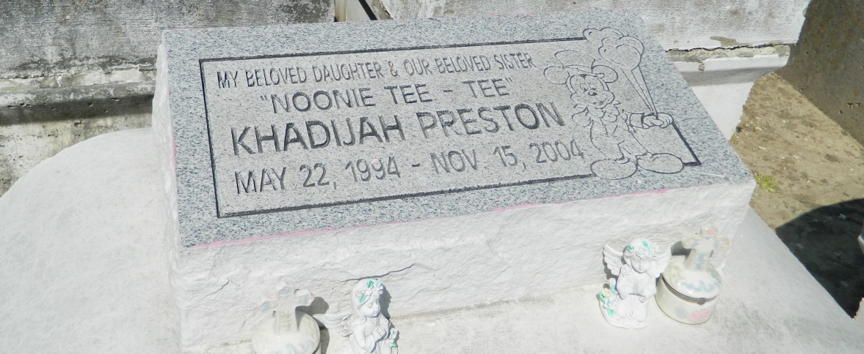

Khadijah "Noonie-Tee-Tee" Preston, a student at Garyville-Mount Airy Magnet School in Garyville, died Monday of a seizure at River Parishes Hospital. She was 10. Khadijah was born in Metairie, had lived in Garyville and lived in Reserve. Survivors include her father, Kelon Gardner Sr.; her mother, Chandra Preston; her stepfather, Alvin Thomas; a brother, Kelon Gardner Jr.; two sisters, Kevia and Kashandra Preston; and her grandparents, Shelia Preston, Theresa Washington and Arthur Davis.

A funeral will be held Saturday at 11 a.m. at Providence Baptist Church No. 2, 152 Union Lane, Montz. Visitation will be today from 5:30 to 7:30 p.m. at Hobson-Brown Funeral Home, 134 Daisy St., Garyville, and on Saturday from 10 to 11 a.m. at the church. Burial will be in Zion Travelers Cemetery.

Times-Picayune, The (New Orleans, LA) - Friday, November 19, 2004
Contributed by Jane Edson

