James Robinson III
June 24, 1980 – April 17, 2005

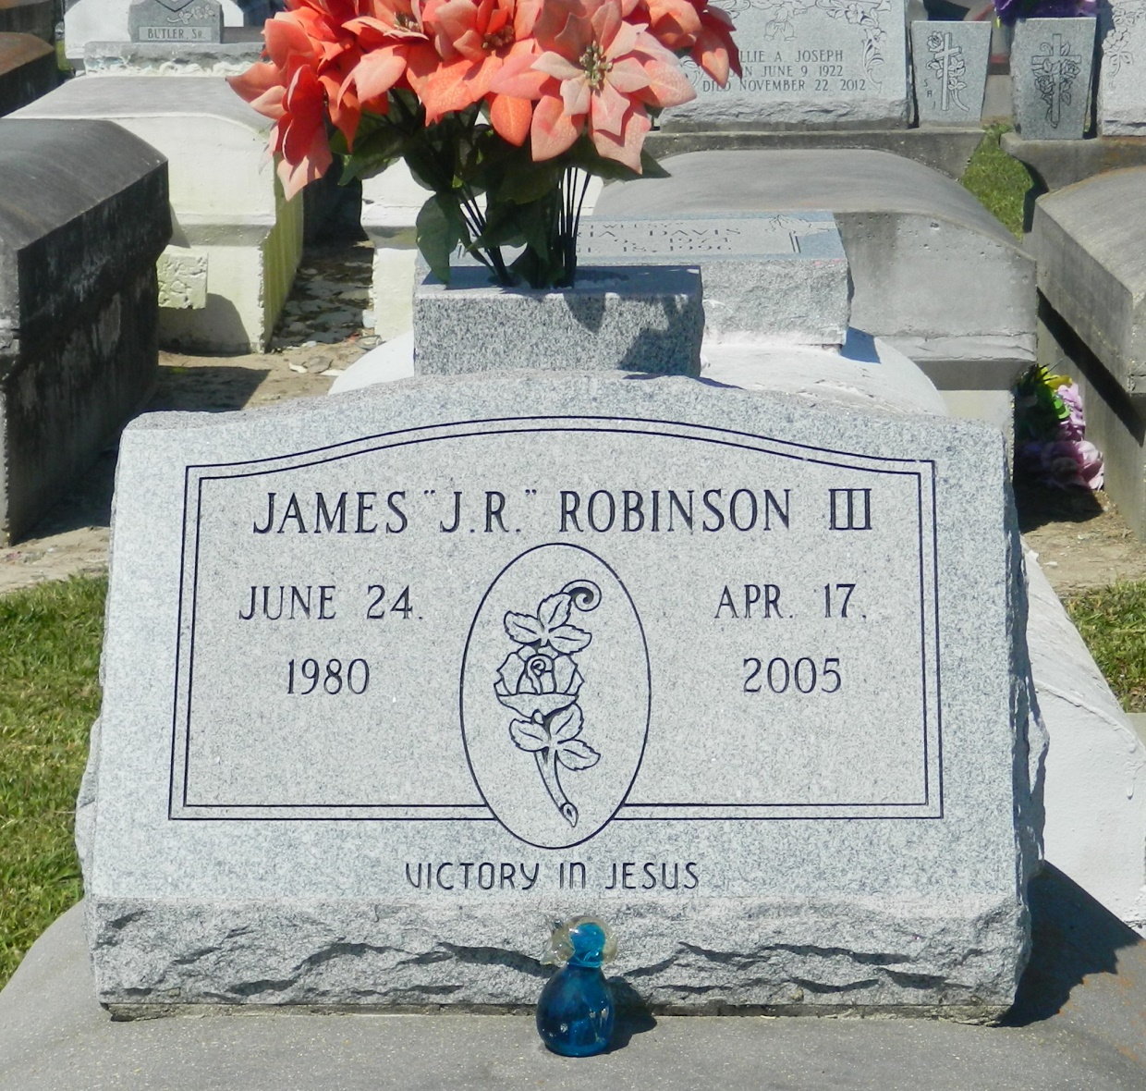

James "Jr." Robinson III, an industrial cleaning laborer, died Sunday at Charity Hospital after being shot in Vacherie. He was 24. Mr. Robinson was born in New Orleans and lived in Mount Airy for 24 years. He attended West St. John High School. Survivors include his fiancée, Tonya Parnell; a son, Jalin Robinson; his mother, Judy Robinson; two brothers, Garland and Gaylin Robinson; two sisters, Gevona Rixner and Gayle Robinson; and his grandmother, Vivian Braxton. A funeral will be held Thursday at 11 a.m. at First Baptist Church, 268 W. 10th St., Reserve. Visitation will begin at 9 a.m. Burial will be in Zion Travelers Cemetery. Bardell's Mortuary is in charge of arrangements.

Times-Picayune, The (New Orleans, LA) - Wednesday, April 20, 2005
Contributed by Jane Edson

