Albert Scott Sr.
December 17, 1910 – January 3, 2006

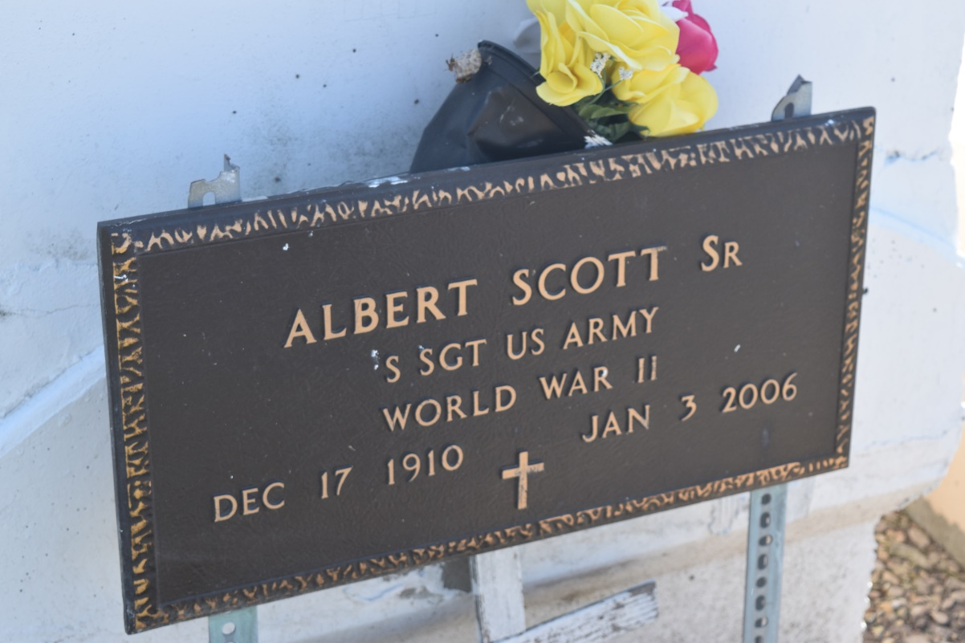

GARYVILLE - Albert Scott Sr., 95, a native and resident of Garyville, died Jan. 3. He was the husband of Thelma H. Scott.He is survived by his children Louis Scott Sr. and Albert (Gaynell) Scott Jr.
He is also survived by his siblings Mildred Norbert and Chester (Dorothy) Lee Sr., seven grandchildren, 13 great-grandchildren, cousin Ella W. Goudia and godchild Reginald Grace.
Services will be held today at 10 a.m. at True Light Baptist Church, Garyville, with interment in Zion Travelers Cemetery.
Hobson Brown Funeral Home is in charge of arrangements. Visitation begins at 9 a.m. at the church.

L'Observateur (La Place, LA) - Monday, January 9, 2006
Contributed by Jane Edson

