Lawrence Smith
July 24, 1943 – February 13, 2011

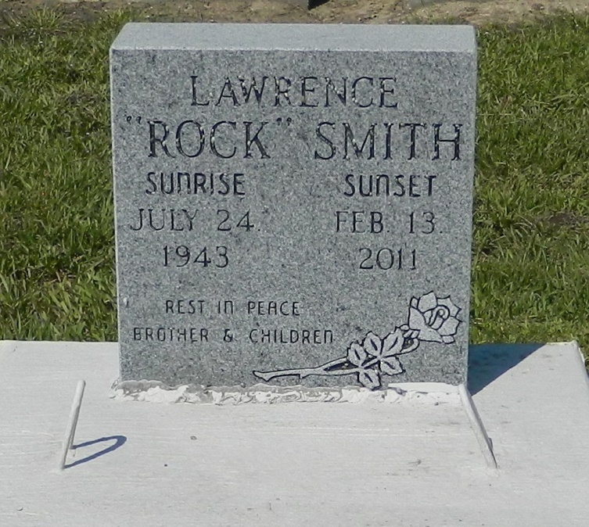

Lawrence (Rock) (Smithy) Smith, Sr., age 67, departed this life on Sunday, February 13, 2011 in Reserve, La. Father of Lawrence Jr., and Lisa Smith. Brother of Clarence Smith and Gaynell Scott. He is survived by grandchildren and great-grandchildren. A resident of Reserve, La.
Service will be on Saturday, February 19, 2011 at 11:00 a.m. at the Rescue Mission B.C., 361 E. 14th St., Rescue, La. Burial in Zion Travelers Cemetery. Visitation will begin at 10:00a.m. until service time.
Service Entrusted to Hobson Brown Funeral Home, 134 Daisy St. Garyville, La., 70051,
(985) 535-2516

Times-Picayune, The (New Orleans, LA) - Friday, February 18, 2011
Contributed by Jane Edson

