Walter Stevens Sr.
January 25, 1937 – September 30, 2011

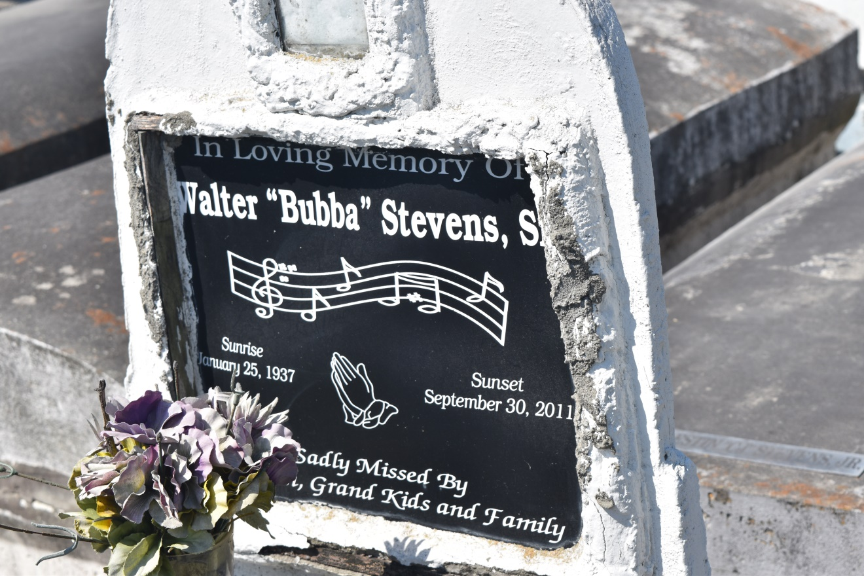

Walter "Bubba" Stevens, Sr., passed away on Friday, September 30, 2011, in LaPlace, La. Father of Sarah Fobb, Patrice and Darrell Powers, Walter and Eileen Stevens, and Donald Ray Telfair. Brother of Evelyn Fleming, Raymond and Thelma Stevens, and Selina McNealy. Also survived by 19 grandchildren, 12 great-grandchildren, sons- and daughters-in-law, and a host of nieces, nephews, relatives and friends.
Funeral Services will be held on Saturday, October 8, 2011 at 10:00 a.m. at New Hopeful B.C., South Fig St., Garyville, La. Burial in Zion Travelers Cemetery. Visitation will be at the Church from 9:00 a.m. until service time. Rev. Roland Morgan Frank, Pastor. Godchaux Henderson, Marathon, St. John Parish Library, and Sheriff Dept., River Security, Club Café, and Louisiana National Guard are invited to attend.
Services Entrusted to Hobson Brown Funeral Home, Garyville, La 70051, (985) 535-2516

Times-Picayune, The (New Orleans, LA) - Friday, October 7, 2011
Contributed by Jane Edson

