Edward Stewart Jr.
August 29, 1960 – May 23, 2002

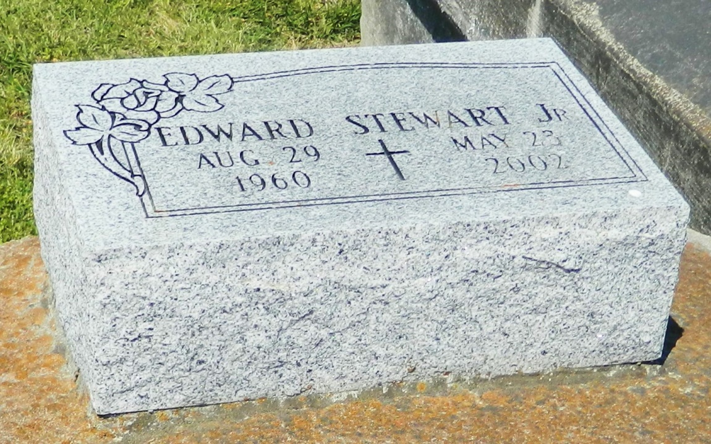

Edward "Lil Pete" Stewart, Jr. departed this earthly life and entered into eternal rest on Wednesday May 23, 2002. Son of the late Maryland Alexis Eugene and Edward Stewart, Sr. Stepson of Johnny Eugene of Reserve, LA. Beloved brother of Vernon E. Alexis, Sr. of Mt. Airy, LA. Stanley Alexis, Sr. of Laplace, LA and Dwight Alexis, Sr. of Kenner, LA. Step brother of Ann Marie Charles, Jacatlia Turley, Ronald Eugene, Wendell Eugene, Warren Eugene, Barbara Eugene of Laplace, LA and Latanya Eugene of Oakland, CA. Also survived by aunts, uncles, other relatives and friends.
Relatives and Friends of the family, also Pastors, Officers and Members of St. Michael Baptist Church of Laplace, LA, St. Mark Baptist Church, St. John Baptist Church of Mt. Airy, LA and all neighboring churches; employees of St. John Parish School Board, E.I. Dupont, Shell Motiva Enterprises and Cottman Transmission are invited to attend the Funeral Services on Thursday May 30, 2002 at 11:00 A.M. at St. Michael Baptist Church, 701 Colony Park Dr. Laplace, LA. Rev. Leroy Sanders, Sr. Officiating. Interment in Zion Travelers Cemetery of Lions, LA. Visitation will be at St. Michael Baptist Church from 10:00 A.M. until service time.
BARDELL'S MORTUARY of Mt. Airy, LA in charge.

Times-Picayune, The (New Orleans, LA) - Wednesday, May 29, 2002
Contributed by Jane Edson

