Loretta R (Songy) Stewart
June 3, 1926 – October 7, 2004

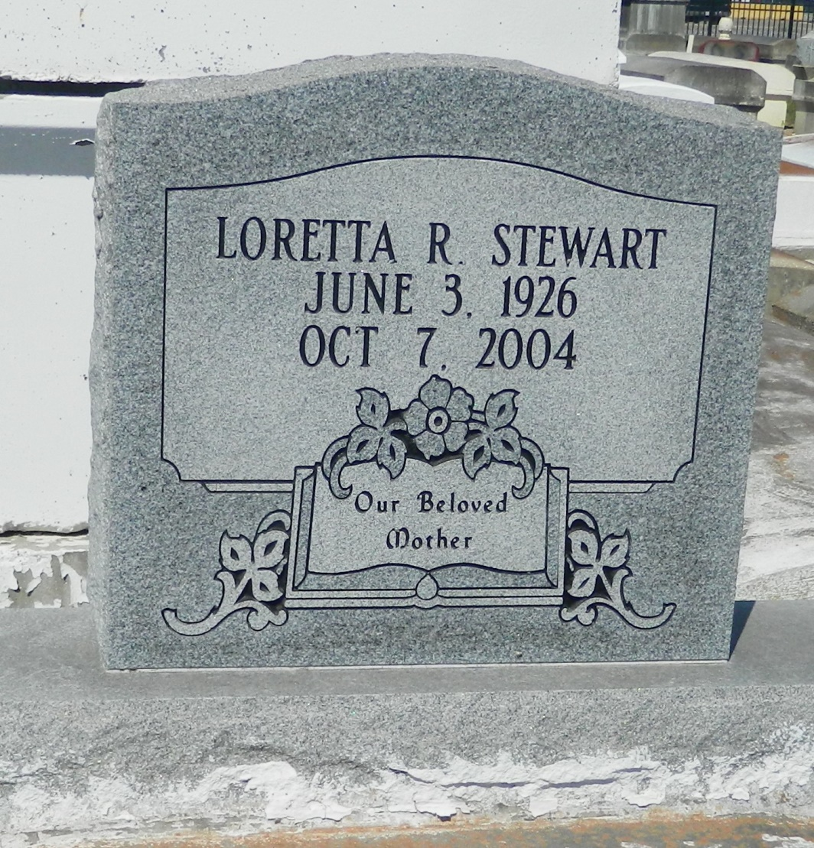

Loretta "Mae Mae" Songy Stewart, a retired technician with the Archdiocese of New Orleans, died Thursday at her home. She was 78. Ms. Stewart was born in Edgard and lived in LaPlace. She was a parishioner of Our Lady of Grace Catholic Church. Survivors include a son, Christopher Stewart; five daughters, Lucretia Eugene of San Diego, Andrea Cambre and Valerie Stewart of Reserve, Michelle Pidgeon and Doris Stewart; three brothers, Oliver Songy Jr. and Donald and Malcolm Songy; two sisters, Eva Duhe and Olivia Keller; 18 grandchildren; and seven great-grandchildren. A Mass will be said Wednesday at 11 a.m. at Our Lady of Grace Catholic Church, 772 Highway 44, Reserve. Visitation will be at 9 a.m. Burial will be in Zion Travelers Cemetery. D.W. Rhodes Funeral Home handled arrangements.

Times-Picayune, The (New Orleans, LA) - Tuesday, October 12, 2004
Contributed by Jane Edson

