Andre Maurice Taylor
April 4, 1980 – October 27, 2003

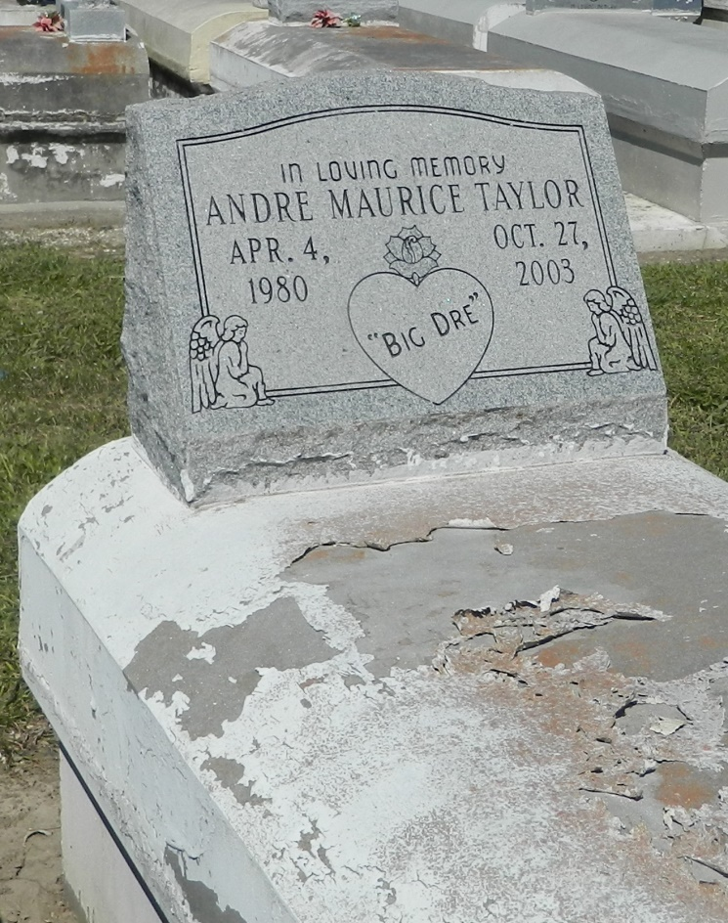

Andre M. Taylor departed this life on Monday, October 27, 2003 in Reserve, LA. Son of Paulette Taylor and Anderson Perrilloux, Jr. Brother of Corey A. Charles, Marcus and Michael Neolnard and Toney Khan. Also survived by a host of aunts, uncles, nieces, nephews, other relatives and friends. A native of Reserve, LA. and a resident of Laplace, LA. Age 23.
Relatives and friends of the family, also pastors, officers and members of New Wine Christian Fellowship, The Greater New Plymouth Rock Baptist Church and all neighboring churches are invited to attend the Funeral services on Tuesday, November 4, 2003 at 11:00 a.m. at New Wine Christian Fellowship, 1929 West Airline Hwy., Laplace, LA. Rev. Neil Bernard, Pastor, officiating. Interment in Zion Travelers Cemetery, Reserve, LA. Viewing will be on Tuesday at 9:00 a.m. until funeral time at the church.
Services Entrusted to Hobson Brown Funeral Home.

Times-Picayune, The (New Orleans, LA) - Monday, November 3, 2003
Contributed by Jane Edson

