Barbara Jean (Mitchell) Taylor
June 23, 1947 – March 10, 2011

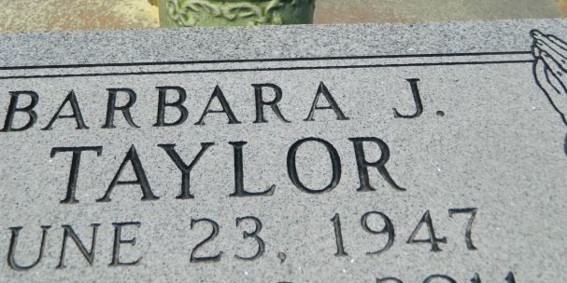

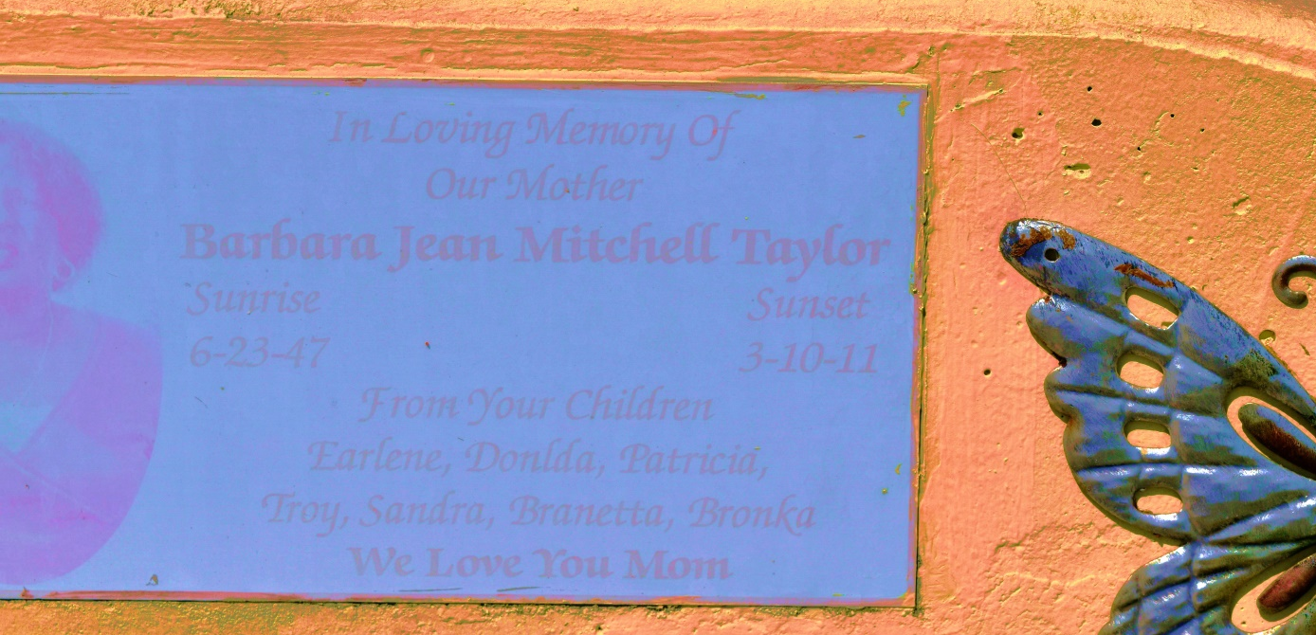

Barbara Jean Mitchell Taylor, age 64, died on Thursday, March 10, 2011. She leaves behind her children: Donald, Troy and Brionca Taylor, Earline Nabors, Patricia Fleming, Sandra Jackson, and Branetta Gibson. Guardian of Ronmaguer Simmons. Sister of Doretha Weston, Shirley Shephard, and Rhonda Ballard and Ray Taplain. Also survived by 16 grandchildren, 10 great- grandchildren, a host of nieces, nephews, aunts, uncles and cousins.
Services will be on Saturday March 19, 2011 at Zion Travelers B.C., 713 Walnut St., LaPlace, La., at 10:00 a.m. Rev. Julius Ellis, Sr., Pastor - Officiating. Visitation at the church from 8:00 a.m. until service time. Interment in Church Cemetery, Reserve, La.
Professional Service Entrusted to Hobson Brown Funeral Home, Garyville, La 70051,
(985) 535-2516

Times-Picayune, The (New Orleans, LA) - Friday, March 18,
Contributed by Jane Edson

