Kelly Taylor
February 9, 1940 – June 7, 2007

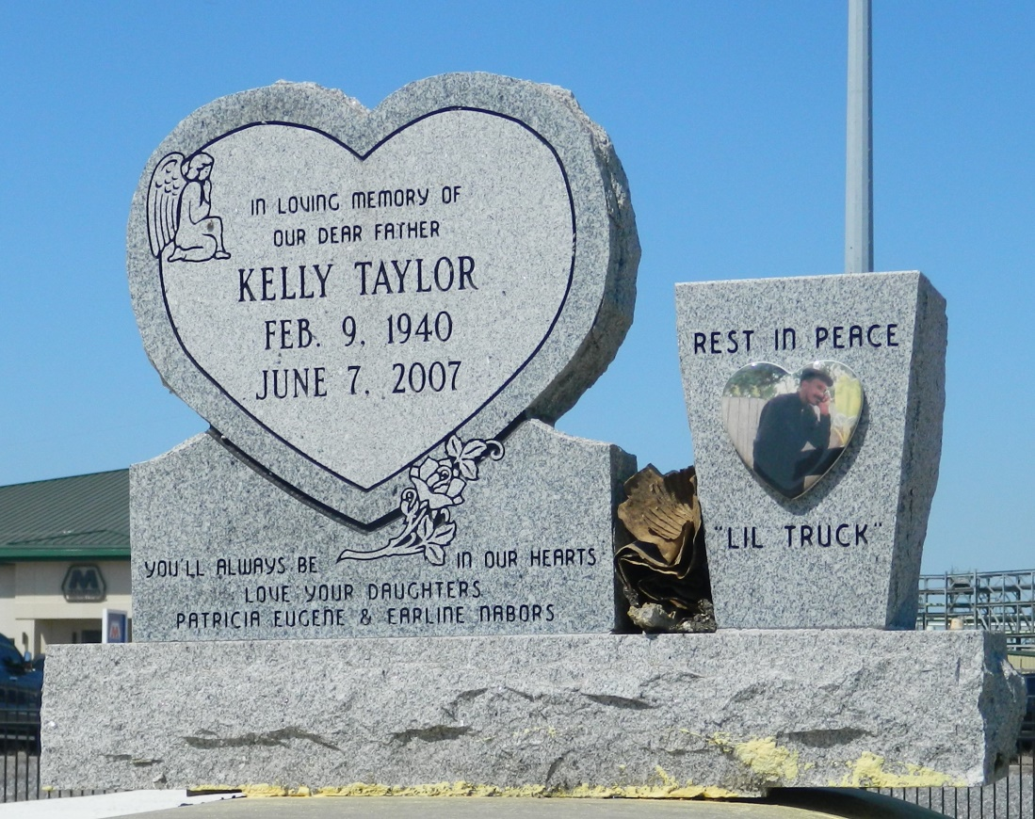

Kelly "Lil Truck" Taylor, age 67, departed this life on Thursday June 7, 2007 in LaPlace, La. Son of Mable Taylor and the late Daniel "Truck" Taylor. Husband of Barbara Taylor. Father of Earline Nabor and Patricia Eugene. Brother of Elnora Freeman, Dora Belvin, Irene Taylor, Linda Davis, Joyce Gautreaux, Audrey Snyder, Daniel Taylor, the late Jerome Taylor, Dale Johnson and Josephine Fobb. Also survived by 4 stepdaughters, 7 stepsons, 2 sons-in-law, 2 aunts, brothers- and sisters-in-law, and a host of grand and great children, nieces, nephews, cousins, and friends. A native and resident of Garyville, La.
Pastor, officers and members of True Light B. C. and all neighboring Churches are invited to attend the Funeral Service on Saturday, June 16, 2007 at 11:00a.m. with a musical at 10:30am the above name church, 258 Little Hope St., Garyville, La. Rev. Wesley Anderson, Sr., Officiating. Interment in Zion Travelers Cemetery, Reserve, La . Visitation on Saturday at the church from 9:00a.m. until service time.
Service entrusted to HOBSON BROWN FUNERAL HOME, Garyville, La. Information: (985) 535-2516

Times-Picayune, The (New Orleans, LA) - Friday, June 15, 2007
Contributed by Jane Edson

