Mable (Cambre) Taylor
April 2, 1919 – December 26, 2007

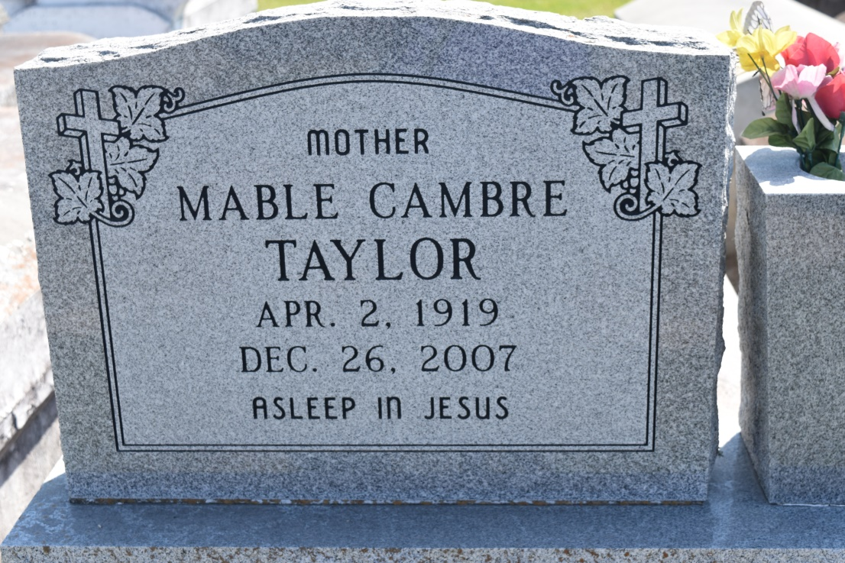

Mable "Ma Mae, Granny" Cambre Taylor, age 88, silently echoed that her departure has come and on Wednesday, December 26, 2007 in Garyville, La. Daughter of the late Christopher and Fedora Cambre. Wife of the late Daniel Taylor and a devoted friend of the late Herman Duroncelay. Mother of Elnora Freeman, Dora Belvin, Irene Taylor, Joyce Gautreaux, and Audrey Snyder, and the late Jerome, and Kelly Taylor and Josephine Fobb. Sister of Ceola Taylor and the late Edith Winfield, Matilda Smith, and Edgar Cambre, Sr. Also survived by a host of sons, daughters, and sisters in law, three generations of grandchildren, great-grandchildren, and great great-grandchildren, and a host of nieces, nephews, other relatives and friends. A native and resident of Garyville, La.
Pastor and members of True Light B.C., and all neighboring churches, employees of Airport Hilton, and St. John Parish School Board are invited to attend the Victory Celebration on Wednesday, January 2, 2007 at 11:00a.m. from the above named church, 258 Little Hope St., Garyville, La.; Rev. Wesley Anderson, Sr., Pastor Officiating. Interment in Zion Travelers cemetery, Reserve, La. Visitation at the church from 9a.m. until Service time.
Service Entrusted to Hobson Brown Funeral Home, Garyville, La.

Times-Picayune, The (New Orleans, LA) - Tuesday, January 1, 2008
Contributed by Jane Edson

