Mercedes Thomas
November 5, 1949 – March 9, 2003

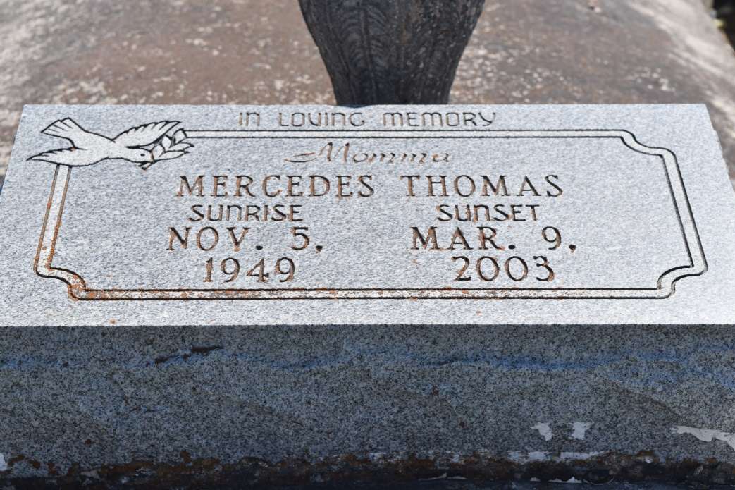

Mercedes Thomas, a homemaker, died Sunday of complications from diabetes at Shelby Regional Medical Center in Center, Texas. She was 53. Mrs. Thomas was born in Reserve and lived in Center. Survivors include two sons, Kenneth Melancon of Los Angeles and Jason B. Thomas of Reserve; two daughters, Carla Orr of Los Angeles and Miracle Thomas; her father, Joe Doss of Fayette, Miss.; her mother, Everlena Melancon of Reserve; three brothers, Keith Doss of Fayette, Miss., and Calvin and Joe Doss; three sisters, Elouise Eugene of Montz, Stella White and Evelyn Basile, both of Reserve; 12 grandchildren; and eight stepgrandchildren.

A funeral will be held today at 11 a.m. at Zion Travelers Missionary Baptist Church, 165 Hickory Road, Lions. Visitation will be at 10 a.m. Burial will be in the church cemetery. Hambrick's Family Mortuary in Gonzales handled arrangements.

Times-Picayune, The (New Orleans, LA) - Saturday, March 15, 2003
Contributed by Jane Edson

