Chenita (Breaux) Tinsley-Reese
April 25, 1957 – August 15, 2008

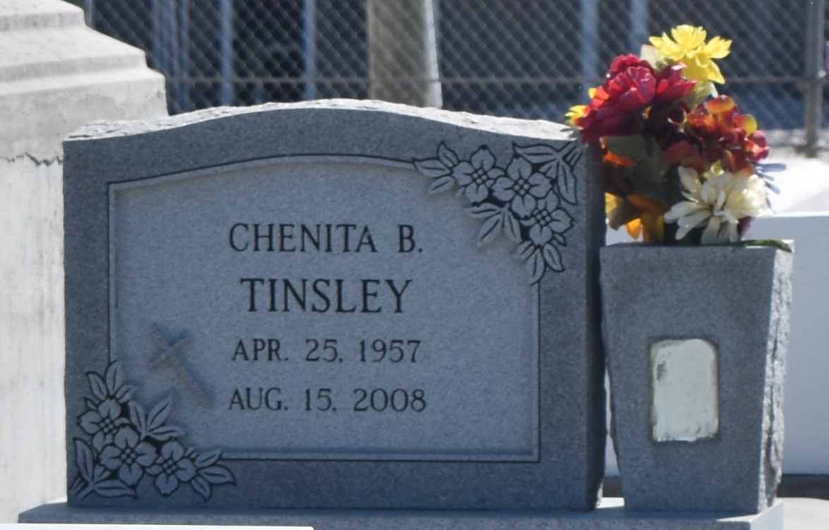

Chenita "Neta" Breaux Tinsley Reese, age 51, T.S.A. Screener, departed this life on Saturday, August 16, 2008, in Marrero, La. Daughter of Raymond and Audrey Breaux. Wife of Chester Reese, Jr. Mother of Robert, Rodney and Nadia Tinsley. Sister Pamela Brown, Lisa Adams, Donna London, Senerca Fredericks, Erika Wilson, Raymond Jr., Ray Anthony, Elton Gerard, Michael, Christopher, Kendall, and Alejandro Breaux. Also survived by eight grandchildren, aunts, uncles, daughters-in-law and a host of nieces, nephews, sisters- and brothers-in-laws, other relatives and friends. A native of Garyville and resident of Reserve.
Visitation and services were held at Beech Grove Baptist Church in Reserve on Saturday, August 23. Interment in Zion Travelers Cemetery in Reserve.

L'Observateur (La Place, LA) - Tuesday, August 26, 2008
Contributed by Jane Edson

