Terry (Suggs) Turner
September 1, 1951 – June 9, 2002

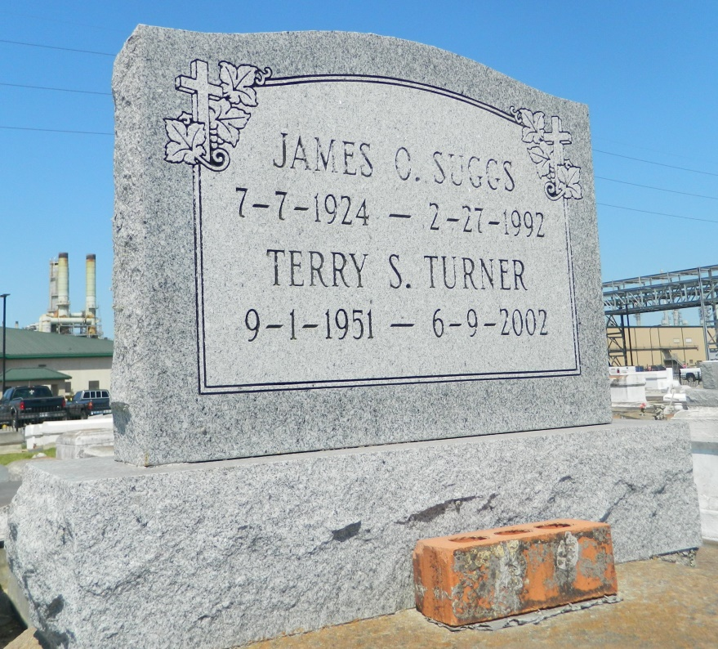

Terry Suggs Turner departed this life on Sunday, June 9, 2002 at Charity Hospital in New Orleans, LA. Wife of the late Eddie Turner. Daughter of Rosia H. Suggs and the late James Suggs. Mother of Charlene S. Kesee of Houston, TX and Ashley Turner of Garyville, LA. Sister of Belinda S. Zeno, James Sr., Bobby and Rev. Perry Suggs, Sr. Grandmother of Marcus and Brianna Kesee. Mother-in-law of Robert Kesee. Sister-in-law of Euris Zeno, and Delma Suggs. Also survived by a host of nieces,nephews, aunts, uncles, relatives and friends. A native and resident of Garyville, LA. Age 50.
Relatives and friends of the family, pastor, officer, and members of True Light B.C., Providence B.C. #1, and the Oakland B.C. Kenner, LA. and all neighboring churches, employees of St. John Parish School Board, St. John Parish Utilities, and Avondale Shipyard are invited the funeral service on Sunday, June 15, 2002 at 11:00 a.m. at the True Light B.C. Garyville, LA. Rev. Wesley Anderson Sr., Pastor officiating. Interment in Zion Travelers Cemetery, Reserve, LA. Visitation will be begin at 10:00 a.m. until funeral time.
Hobson Brown Funeral Home in charge of arrangements.

Times-Picayune, The (New Orleans, LA) - Friday, June 14, 2002
Contributed by Jane Edson

