Henry Tyler, Jr.
December 28, 1949 - December 6, 2022
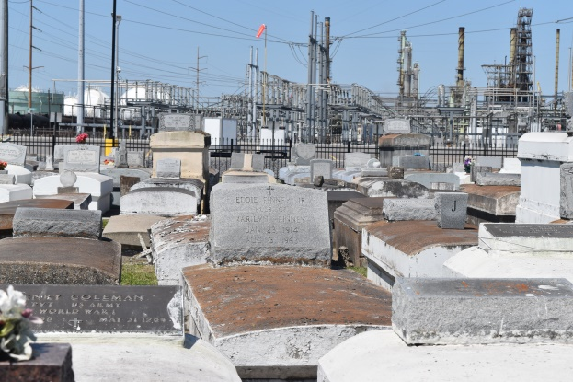

On the morning of December 6, Henry Tyler, Jr. went home to be with the Lord. He was born to the union of the late Henry Tyler, Sr. and Birthella Tyler.
Tyler attended St. John the Baptist Parish School District where he graduated from Fifth Ward High School. He was an outstanding football player during his high school years. After high school, he married the love of his life, Madelyn Sanders. To this union, their beautiful daughter, Charmaine Tyler and a handsome son, Ronald Tyler were born. Tyler worked as a welder for much of his life with the companies, Bayou Steel and Avondale Shipyard to name a few until his retirement.
He accepted the Lord at Ochsner Hospital in Metairie on his sick bed. He believed that God is his Lord and Savior, and he gave his life over to him.He would always say to Madelyn during his time of sickness, “Don’t worry about him. Take care of yourself and that he loves her.”
Tyler’s life will be forever remembered by his loving family and friends, his children, Ronald Tyler (Fernada), Charmaine Tyler, and Valerie Anderson (Maurice). His sisters: Rhonda Eugene (Charles), Gwendolyn Brown, Marie Smith (Albert), and Beverly Smith; Brothers: Kerry Tyler (Ophelia), and John Alexander. Adopted sisters and brothers: Matthew, Diane, Kendrick and Calvin Morgan, Cheryl Stephens, Bernadine Brown, Marva Hildreth, Beatrice Edwards, Tyneka, Kavonna, and Nettie Tyler. Grandchildren; Iriel Tyler (Bralyn and Blaise), Imani Tyler, Joshua, Antoine, Juan, Ronald (RJ), and Devin Brumfield, Chance Tyler, Ja’Kobi, and Ja’Kai, Anderson and Ja’Kniya Perkins, a host of nephews, nieces, great-nieces, great-nephews, cousins, other relatives, and friends.
He is proceeded in death by his parents, Henry and Berthella Tyler; Sisters, Odelia Potts (James), Barbara Fenderson (Charlie), Mary Ellis, Oretha Bell, and Patricia James. Brothers: Sam Tyler (Reagan), Cortney Tyler, Larry and Joseph Anderson, and great nephew, Ramond Moore; Aunts: Aldonia Joseph and Lelila Brown.
Relatives and friends of the family, Pastors, Officers and Members of Milesville Memorial Church of God in Christ and all neighboring churches are invited to a Celebration of Life on Saturday, December 17, 2022 at 11:00am at Milesville Memorial Church of God in Christ, 129 Apple Street, LaPlace, LA 70068. Visitation at the above-named church 10:00am until time of service. Interment Zion Travelers Cemetery, Reserve, LA. Final Arrangements Entrusted to Patrick H. Sanders Funeral Home & Funeral Directors, Inc. 605 Main Street, LaPlace, LA 70068. For information 985-359-1919.

The Patrick H. Sanders Funeral Home, LaPlace, Louisiana

