Kerry Tyler
March 21, 1962 - April 10, 2023

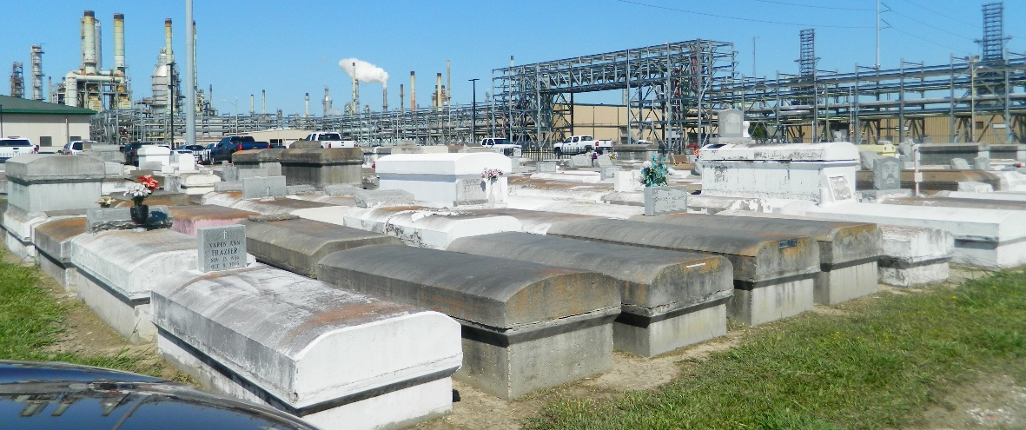

Bro. Kerry Tyler passed from earth to eternity on Monday, April 10, 2023. He was born on March 21, 1962 to the union of Henry, Sr. and Birthella Tyler of Reserve, LA. He was baptized at Beacon Light Baptist Church of LaPlace, LA. Bro. Henry attended the St. John the Baptist Parish School System. He was employed at A3M in Reserve, LA until he became ill.
Bro. Kerry was married to his loving wife, Ophelia Richardson Tyler. He had one daughter, Kerriandra Tyler and two grandchildren, Kameryn Cooper and Karsyn Tyler.
Bro. Kerry leaves to cherish his memories his wife, Ophelia, daughter Kerriandra, two grandchildren, sisters, Rhonda (Charles), Gwendolyn Brown, Marie (Albert) Smith, Beverly Smith, brother, John Alexander, sisters-in-law Marilyn Tyler and Alice Richardson, Godchild, Jaden Robertson, Sr. He also leaves to cherish his memories, his adopted sisters and brothers and a host of nieces, nephews, cousins and other relatives and friends and the Zion Travelers Missionary Baptist Church Family.
He was preceded in death by his parents, Henry, Sr. and Birthella Tyler, sisters; Dorothy Ellis, Oretha Bell, Odelia Jackson and Barbara Tyler, brothers; Henry Tyler, Jr., Sam Tyler and a great nephew, Raymon Moore.
Relatives and of the family, Pastors, Officers and Members of Zion Travelers Baptist and all neighboring churches are invited to the Celebration of Life at 11:00 am on Saturday, April 22, 2023 at Zion Travelers Baptist Church, 713 Walnut Street, LaPlace, LA 70068. Visitation 10:00am until time of service at the above-named church. Interment Zion Travelers Cemetery, Reserve, LA.

Patrick H. Sanders Funeral Home, LaPlace, Louisiana
July 31, 2023

