Alvin Williams Jr.
February 20, 1957 – August 17, 2007

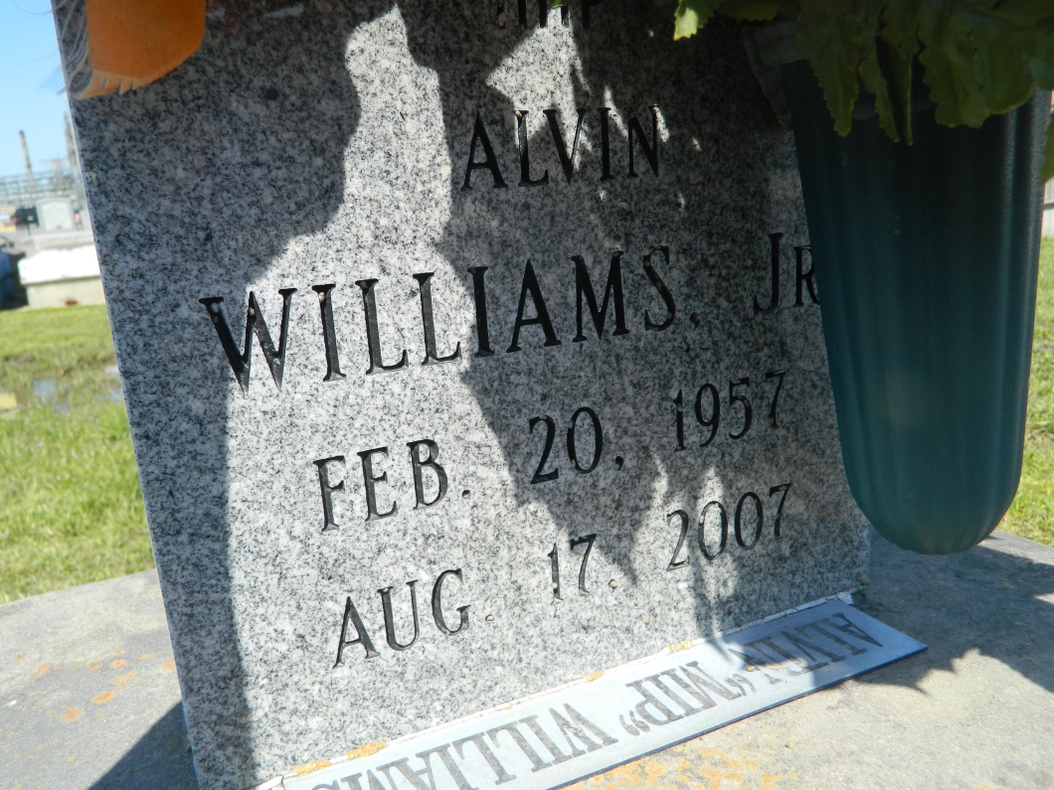

Alvin "Mip" Williams, Jr., age 50, departed this life on Friday, August 17, 2007 in Baton Rouge, La. Son of the late Delores Houston and Alvin Williams, Sr. Father and father in law of Cardell (Hazel) George. Nephew of Emelda Johnson, Rita Crocker, Rosemary Moore, Villere, Horace, and Leroy Houston, Curtis, Larry, and Gene Williams, and James Sheppard. Also survived by stepmother, Gail Williams; 1 grandchild, Yazmine Hookes; and a host of cousins, other relatives and friends. A native and resident of Reserve, La.
Pastor, Officers, and Members of St. Mark B.C. and all Neighboring Churches are invited to attend the Funeral Service on Thursday, August 23, 2007 at 11:00a.m. from 132 Marques St., Mt. Airy, La., Rev. Oscar Nelson, Pastor, Officiating. Interment in Zion Travelers Cem., Reserve, La. Visitation at the church on Thursday from 9a.m until Service time Service. (ONLY)
Service Entrusted to Hobson Brown Funeral Home, Garyville, La.

Times-Picayune, The (New Orleans, LA) - Wednesday, August 22, 2007
Contributed by Jane Edson

