Charles F. Williams
February 13, 1931 – April 19, 2007

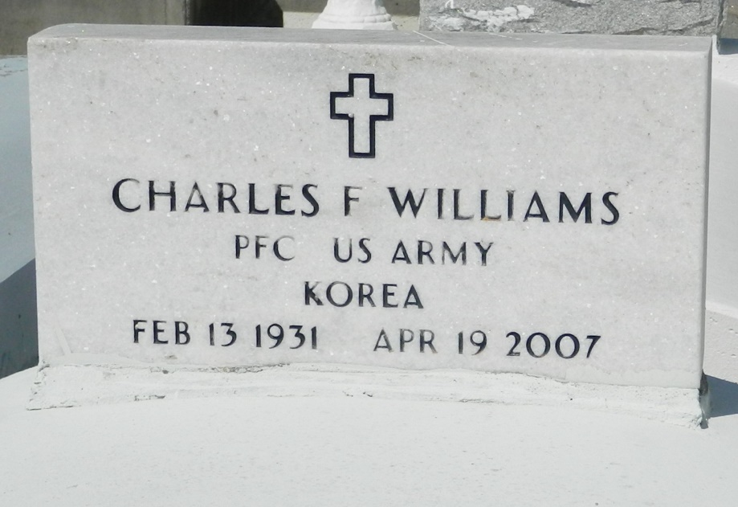

Charles F. Williams, of Garyville, LA, at River Parishes Hospital, Laplace, LA, on Thursday, April 19, 2007, departed this earthly life. Beloved husband of Pearl E. Williams. Son of the late Eddie and Rosa Williams Sr. Beloved father of Barbara D. Williams. Brother of Eddie Williams, Jr. (Millie), Frank Williams Sr. (Brenda), Raymond Williams (Odessa), and the late Deloris W. Johnson and Evelyn W. Harris. Godfather of Connie M. Sterling. Nephew of Albertha Walker, of Houston, TX. Devoted uncle of Hemon Harris, Jr and Cynthia Harris Cook. Also survived by other nieces and nephews, great-nieces, great-nephews, cousins and friends. A native and resident of Garyville, LA. Age 76 Years.
Relatives and Friends of the Family, also Pastor, Officers and Members of the True Light B.C. and neighboring churches, Fifth Ward High School, Class of "51", employees of Wal-Mart, St. John Parish School System, V.A. Medical Center, River Parishes Hospital and Unity Health, and former employees of Emile Hotard Sr. 7-UP Distributing Co., are invited to attend the funeral services on Saturday, April 28, 2007, at 12:00 Noon from the True Light B.C., 258 Little Hope St., Garyville, LA. Rev. Wesley Anderson, Sr., Officiating. Interment Zion Travelers Cemetery, Reserve, LA. Visitation on Friday, April 27, 2007, 4pm-7pm, from the Baloney Funeral Home, 399 Earl Baloney Dr., Garyville, LA, and Saturday, April 28, 2007 at the church after 9:00 A.M.
THE BALONEY FUNERAL HOME, LLC, 399 Earl Baloney Dr., Garyville, LA 70051,
985-535-2540 in Charge Of The Arrangements.

Times-Picayune, The (New Orleans, LA) - Friday, April 27, 2007
Contributed by Jane Edson

