Clarence “C.W.” Williams

March 16, 1955 – November 8, 2022

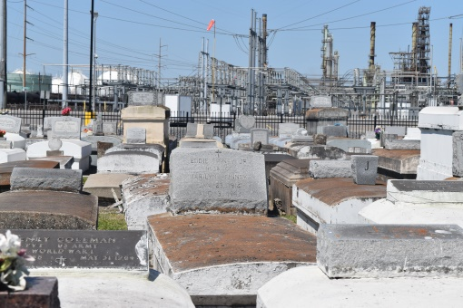

Clarence Williams entered into eternal rest on Tuesday, November 8, 2022 at the age of 67. Clarence was born on March 16, 1955 in New Orleans, Louisiana to the late Ceolia and the late Alphonse Williams. He was the sixth child of 11 siblings. He was the beloved husband of Jackie Francois-Williams.
He accepted Christ at an early age. He was baptized at Macedonia C.O.G.I.C. He later moved to Baton Rouge, LA. where he was the owner of Full Spectrum Investigation Agency and also the owner of C.W. Commercial Cleaning Service. He studied at Tulane University and later transferred to Baton Rouge Community College receiving his Associate Degree in Paralegal Studies.
Clarence was a faithful prayer warrior, encourager and giver who always loved to encourage the younger generation. He was a mentor at Istroma High School and Melrose Elementary.
He leaves to cherish his memories with his wife Jackie Francois- Williams, daughter Toshiba Birch and Step daughters, Brittney Francois Jackson, Briana Francois and Bianca Holmes. (9)Siblings - Joyce Peters, Alvin (Linda) Williams, Sheryl Jones, Lionel Williams, Alphonse Williams, Glenda Williams, Carla (Charles) Magee, Kevin Williams and Sharlita Williams. (14) Grandchildren and a host of nieces, nephews, relatives and friends.
He's preceded in death with his son Corvell Johnson. Parents Ceolia and Alphonse Williams. Sister; Marie Antoinette Rochon. Nieces and Nephews; Aaron and Lionel Jones, Joshua McElveen, Chanell, Lisa and Michelle Mitchell. Aunts; Eva Mae Simmons and Barbara Washington.
Relatives and friends of the family, Pastors, Officers and Members of Macedonia Church of God in Christ and surrounding churches are invited to attend the Celebration of Life and Legacy at 11:00 am on Saturday, November 19, 2022 at Macedonia Church of God in Christ, 3015 Louisa Street, New Orleans, LA 70126. Visitation 9:00am until time of service at the above-named church. Interment Zion Travelers Cemetery, Lions, LA 70084. There will also be a public visitation on Friday, November 18, 2022 from 4 to 6pm at the Patrick H. Sanders Funeral Home, 605 Main Street, LaPlace, LA 70068. Final Arrangements Entrusted to Patrick H. Sanders Funeral Home & Funeral Directors, Inc. 605 Main Street, LaPlace, LA 70068. For information 985-359-1919.

The Patrick H. Sanders Funeral Home, LaPlace, Louisiana

