Delores Mary “Dee” Houston
February 5, 1935 – July 15, 2004

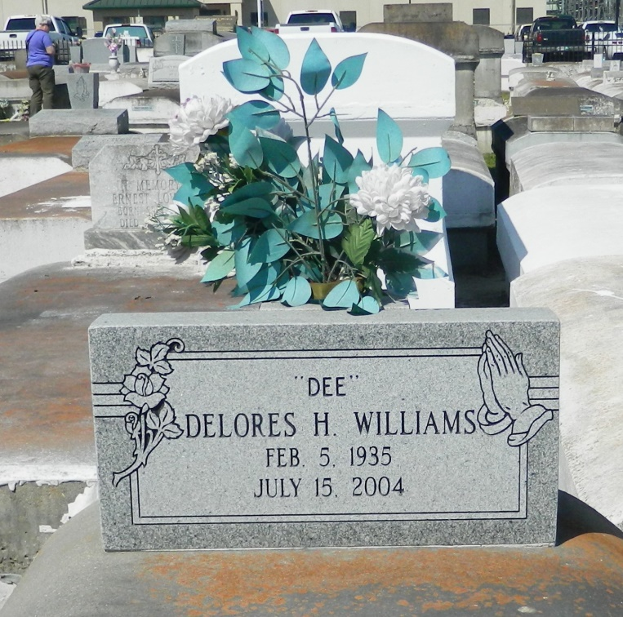

Dolores Mary "Dee' Houston Williams departed this life on Thursday, July 15, 2004 at her residence Reserve, LA. Daughter of the late Villere Sr. (Levy) and Louise Nelson. Beloved mother of Alvin "Mip" Williams, Jr., of Reserve, LA. Sister of Horace Houston of Oakland, CA, Emelda Houston Johnson, Villere (Billy) Jr. and Leroy Houston of Reserve, LA, the late Herman and Levy (Sonny) Houston. Survived by 1 grandchild, Cardell Walker, also survived by 4 sisters in law: Mrecedes Houston of Oakland, CA, Cynthia and Joyce Houston of Reserve, LA and Annette Houston of LaPlace, LA; 1 niece, Marcel Nelson of Mt. Airy, LA; and a host of nieces, nephews, cousins and friends. A native and resident of Reserve, LA. Age 69.
Relatives and friends of the family, also pastor, officers and members of St. Marks Baptist Church, and all neighboring churches, employees of Constar Plastics, ISS Janitorial Services, and Members of the Pirates Baseball Organization are invited to attend funeral service on Wednesday, July 21, 2004 at 11:00 a.m. at the above named church 132 Marquez St., Mt. Airy, La., Rev. Oscar Nelson Pastor Officiating. Interment in Zion Travelers Cemetery, Reserve, La. Visitation on Wednesday 10:00 a.m. until service time.
Service entrusted to HOBSON BROWN FUNERAL HOME, Garyville, LA

Times-Picayune, The (New Orleans, LA) - Tuesday, July 20, 2004
Contributed by Jane Edson

