Larry J. Winfield
February 21, 1948 – September 20, 2006

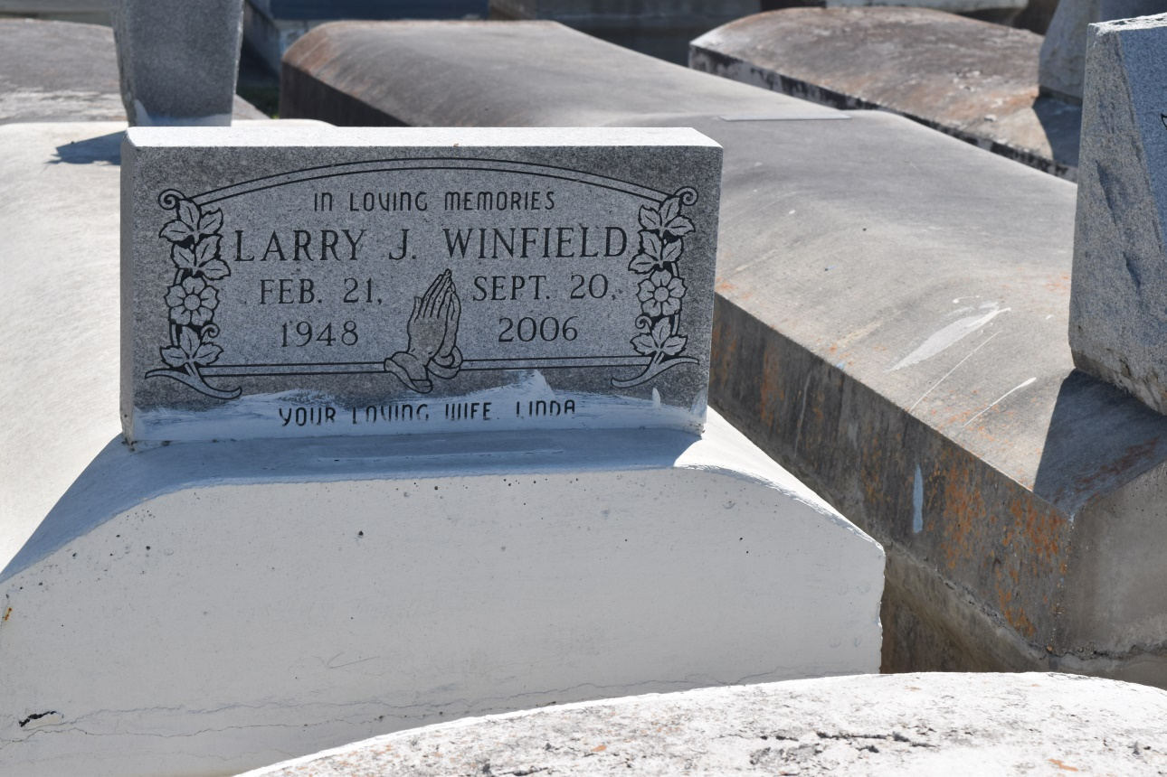

Larry "Jinx" Winfield, age 58, departed this life on Wednesday September 20, 2006 in Jefferson, La. Son of the late Louis and Sarah Winfield, Husband of Linda Butler Winfield. Father of Saynara W. Mason, Sanavia Winfield, Deidre Harrison Alexdra Johnson, Delores Anderson, Craig James, Sherry Randall, and Larry Winfield. Survived by 12 grandchildren, aunts, uncles, nieces, nephews, sisters, brother, other relatives and friends. A native and resident of Garyville, La.
Pastor, officers and members of True Light B.C., Mt. Zion B.C. # 1, and all neighboring churches; employees of St. John Parish School Board and Garyville Magnet School; employees of Egan Home Care, # 377th Theater Sustainment Command Belle Chase, La., are invited to attend service on Saturday, September 30, 2006 at 12:00 noon, 258 Little Hope St. Garyville, La. Rev. Wesley Anderson Pastor, Officiating. Interment Zion Travelers Cemetery, Reserve La. Fiewing at the church from 10:00a.m. until service time.
Service entrusted to HOBSON BROWN FUNERAL HOME, Garyville, LA

Times-Picayune, The (New Orleans, LA) - Friday, September 29, 2006
Contributed by Jane Edson

