Nellie Mae J. Young
September 24, 1934 – May 19, 2005

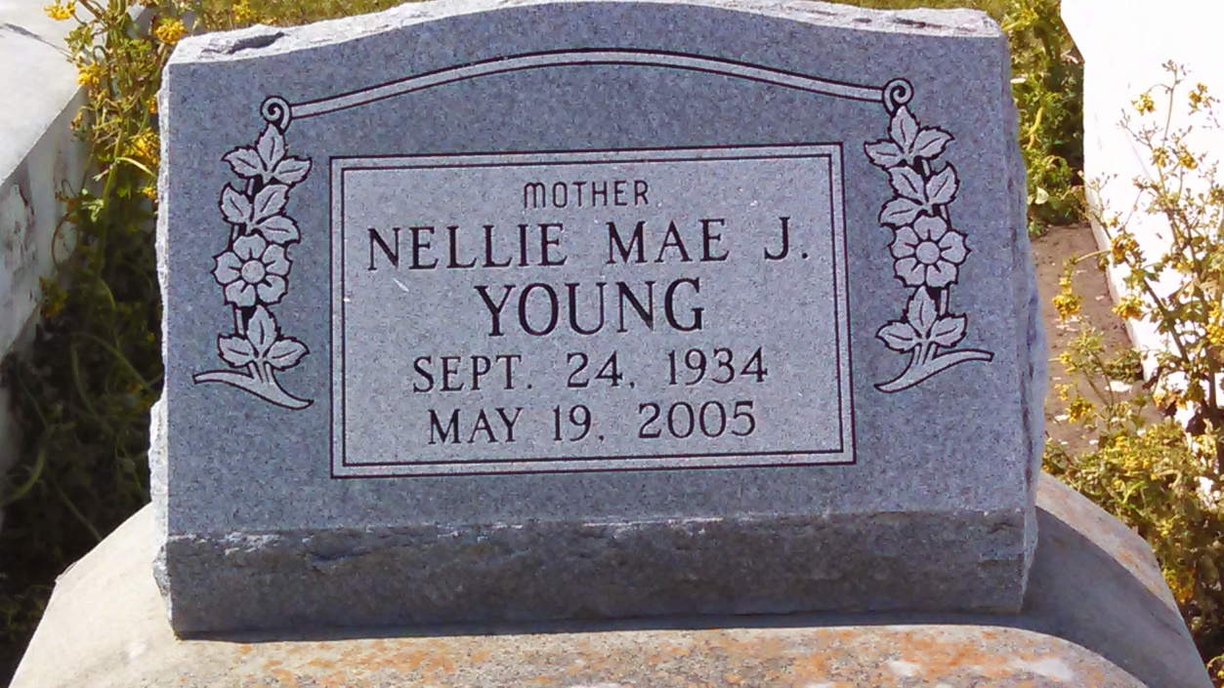
Photo by GeniHound

Nellie Mae Jones Young, departed this life on Friday, May 19, 2005 at her residence in Garyville, LA. Daughter of the late Martha Jones. Wife of Freddie Young, Sr. Mother of Cheryl Sambrone, Darlene Aubert, Arlene, Bruce, Bryan, Merlin and Freddie Young, Jr. Sister of Joseph L. Jones. Also survived by (3) daughters-in-law: Sheri Jackson, Charlene Young, and Elisha Raynae Young, (1) sister-in-law Mary Jones, (21) Grandchildren, (4) Great grandchildren, and a host of other relatives and friends, a native and resident of Garyville, LA. Age 70.
Relatives and Friends, Brothers, Officers and members of Kingdom Hall of Jehovah's Witness Lutcher Congregation and all neighboring churches are invited to attend the funeral service on Wednesday, May 25, 2005 at 11:00 a.m. from the above named Kingdom Hall, 2963 Admirals Landing St. Paulina, LA., Brother Milton Douglas, officiating. Interment in Zion Travelers Cemetery, Reserve, LA.
Visitation on Tuesday at the funeral home, 134 Daisy St. from 5:30 p.m. until 7:30 p.m. and on Wednesday, May 25, 2005 frtom 9:00 a.m. until service time.
Service Entrusted to Hobson Brown Funeral Home, Garyville, LA

Times-Picayune, The (New Orleans, LA) - Tuesday, May 24, 2005
Contributed by Jane Edson

